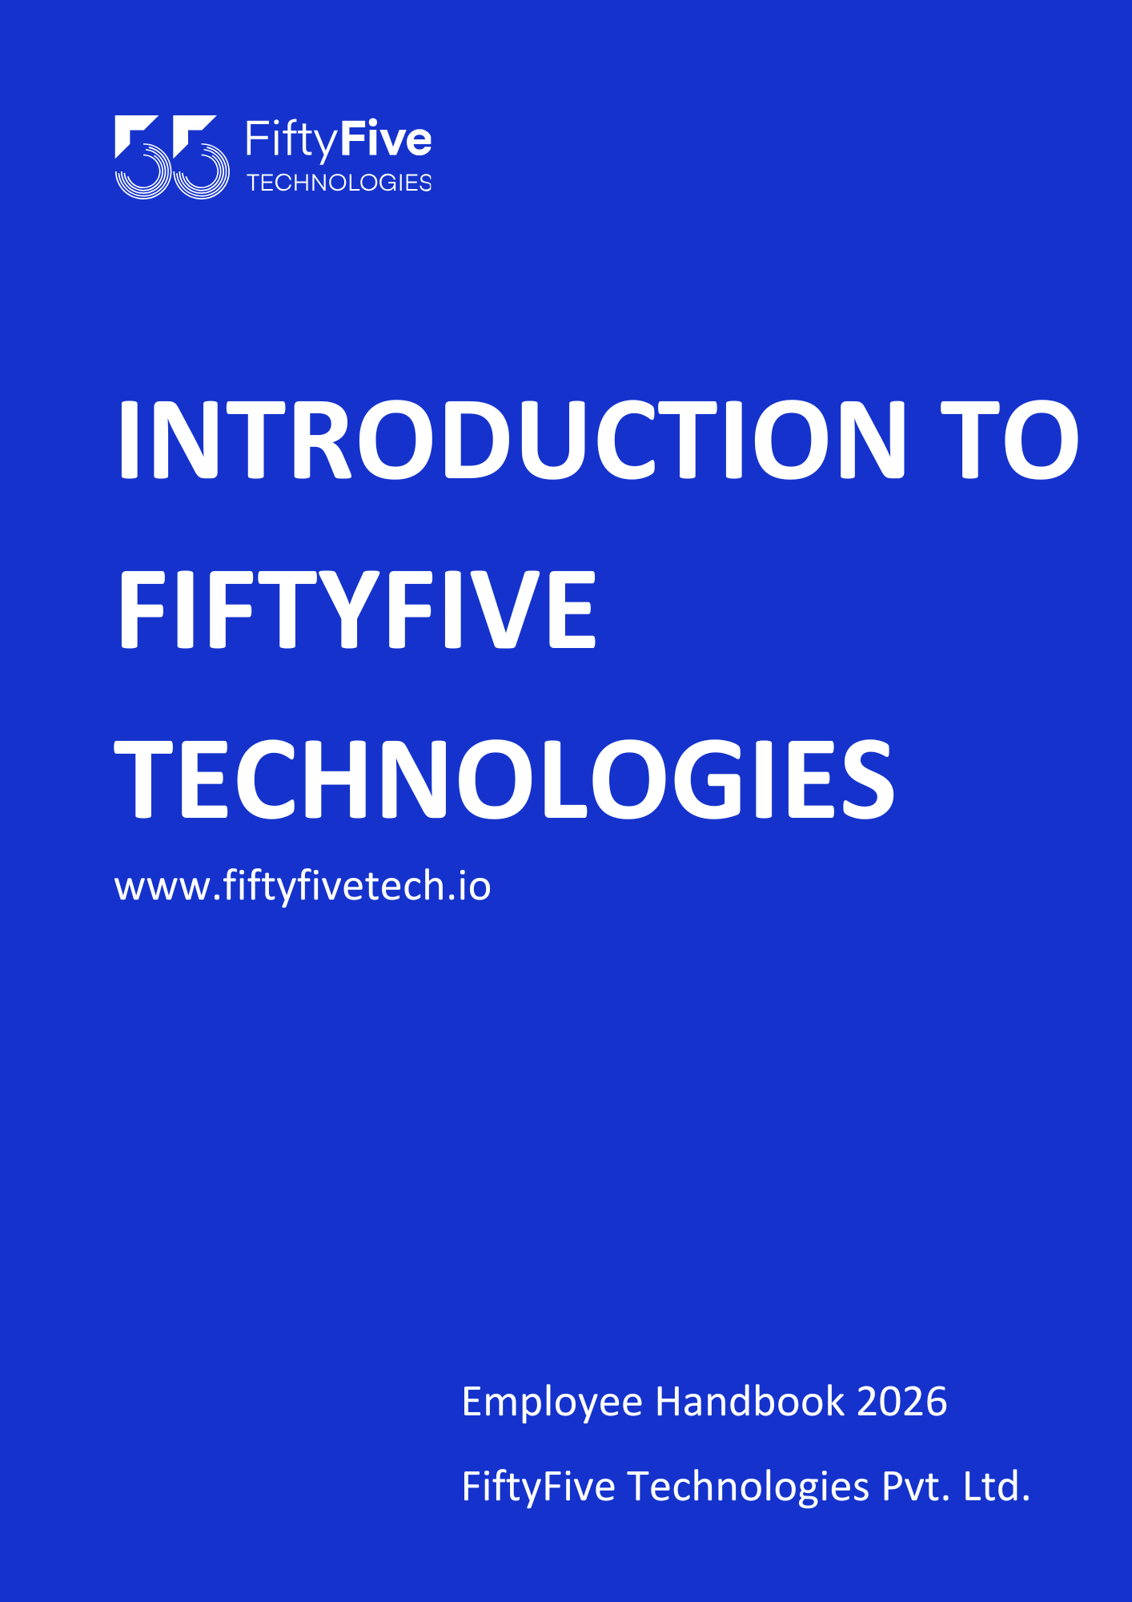

ABOUT US

FiftyFive Technologies is a Technology-empowered IT outsourcing company founded in 2016 in Jaipur, Rajasthan. We are relentlessly broadening our horizons and we have offices in Jaipur, Gurugram, Indore, London (United Kingdom), Dubai (UAE). As a Multinational Corporation, we are stretching ourselves to the prominent business locations across the globe.
As an outsourcing company we provide a diverse array of consulting & development services to the top HNI customers operating in IoT, AI, Gaming, Energy, FinTech, Travel & Manufacturing, etc sectors.
Having launched our own games, we are now positioned as a progressive gaming company with a strong product portfolio. This marks the evolution of our product-driven side, focused on creativity, scalability, and global reach.
FiftyFive Technologies is not operating as an organization full of Work Zombies giving tones of work.
Instead, we are a family, we want to create fun-loving stories at the workplace with flexible hours, a hybrid structure, and a jovial environment. In order to avoid beating around the bush, “We are a culturally inclined Family”.

Our Vision
At FiftyFive Technologies, we’re not just about tech; we’re about creating a vibrant, people-first culture that celebrates work-life harmony. We envision a workplace where every team member feels like a valued part of the FiftyFive Family, working in an open and dynamic environment where innovation thrives.
Our goal is to build a company powered by cutting-edge technology and extraordinary people—a company that propels businesses into the future while prioritizing trust, transparency, and satisfaction for both clients and employees.
We’re committed to uncovering hidden talent from every corner of India, especially from smaller cities where big dreams often face limited opportunities. Our vision is to provide a platform where talent can shine, careers can thrive, and boundaries are redefined.

Our Mission
We’re on a mission to grow our family to 500+ exceptional individuals, all united by a passion for creating outstanding solutions. To achieve this, we’re not just scaling heights—we’re redefining them.
From launching our groundbreaking in-house gaming product to rolling out a state-of-the-art travel app, we’re paving the way for innovation. As we aim to become the go-to game development service provider for global companies, our focus remains steadfast: enabling businesses to evolve with technology and delivering unparalleled value every single day.
Join us as we push the boundaries of what’s possible—together.

Values we Patronize

Care for Our Planet and Society
To us, the planet is more than just a home—it’s our shared responsibility. We are deeply committed to nurturing our ecosystem and giving back to the society that sustains us.

Care for Our People
At FiftyFive Technologies, our people are our greatest strength—the foundation and the force behind everything we achieve. We are passionate about their growth, well-being, and success, fostering an environment where they can thrive.

Care for Our Customers
Our customers are the heartbeat of our journey. We are dedicated to their success, walking with them through every step of their product development and transformation. Their victories are ours too, fueling our shared growth and innovation.

Care for Technology
Our belief in technology goes beyond the surface. Guided by our tagline, “Culture Beyond Tech,” we embrace technology as a transformative force for good, enabling people to experience its full potential and shaping a better tomorrow.

